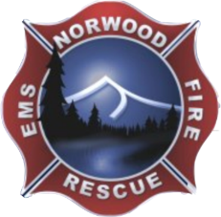 June 19, 2024

Board of Directors Meeting CANCELLED for June.

In Lieu of Meeting Minutes, Chief’s Report of Monthly Activities:

The following is my report on happenings in the department.

1) May total calls: 43
EMS - 39, 18 transports
Fire - 4, including one gas leak
2) First "Town Hall Meeting '' for the mill levy seemed to go well. Everyone that attended appeared to be in favor. However, I'm playing the pessimist and expecting a "silent majority" is not for it! I hope to reach those people at some point. Thank you to Jim, Vivian and Wendy for attending. We will hold the next public meeting on Saturday, August 17th at 0900. We will also have a meeting in Redvale at the Community center in September, date to be determined.
3) Our crews were the first engine crew to arrive at the Gut fire, Clay Creek. The fire was on Forest Service land, but they asked if we could stay and help. Forest service actually put us on as a resource and our crews will be getting paid by the Feds. They also requested our Tender to come back and supply water. All in all, two days and the crews did an amazing job stopping that fire!
4) Wildland team should be next up in the area to deploy.
5) We had a table at Music on the Mesa this past Sunday and passed out our new brochures on the mil levy. Again, positive feedback.
6) I'm continuing to work with our new bookkeeper and payroll company. Trying to work out the bugs. It will be more work for me, but hopefully worth it in the long run.
7) I will be attending a Homeland Security Threat Liaison Officer program in Golden in July. This is by invitation only and thank you to Jim for the letter of recommendation.
8) I have communicated with the Town and we are good to go for the "new" Star Spangled Saturday on July 6th.
9) Ambulance 1 is finally back in service and so far, running great!

That's all I have for now, please reach out with any questions or concerns.

Respectfully,

John

